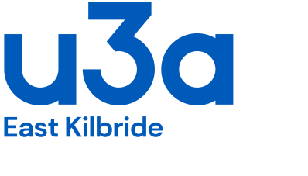

Members’ Code of Conduct

Purpose
The Member Code of Conduct clarifies the standard of behaviour expected of each u3a member.

Scope
Relevant to all u3a in EK members.

u3a in EK is a self-managed learning organisation where members share knowledge, skills, and experiences in an inclusive and respectful environment. Members, including group leaders and committee members, give their time voluntarily towards the running of the organisation, there are no salaried positions. This Code of Conduct outlines the principles that all members are expected to uphold.

In general:
- Members are expected to know, follow and promote the principles of the u3a Movement as listed in our Welcome letter.
- Members must always act in the best interests of u3a in EK and the u3a Movement, strive to uphold its reputation and never do anything which could bring their own, another u3a or the u3a Movement into disrepute or expose it to undue risk.

In particular:
- Respect and Inclusion
All members shall treat each other with courtesy, kindness and respect, embracing diversity and ensuring an inclusive and welcoming environment. When involved in u3a activities, they must not exhibit any form of abuse or inappropriate behaviour either face to face or via u3a social media platforms.

- Participation and Engagement
Members are encouraged to participate actively in u3a activities, contribute their knowledge, and support the learning community in a positive and constructive manner.

- Ethical Conduct
Honesty, integrity, and fairness should guide all interactions and activities. Members should uphold the reputation of u3a in EK and the u3a Movement avoiding conflicts of interest and undue risk.

- Safe and Supportive Environment
Members must ensure that u3a in EK events and activities are conducted in a safe, supportive, and non-disruptive manner, free from harassment, discrimination, or intimidation.

- Confidentiality and Privacy
Personal information of members must be respected and handled with care. Members should not disclose private details of another member without consent.

- Responsible Use of Resources
u3a in EK resources, including facilities being used, materials, and finances, should be used responsibly and solely for the benefit of the organisation and its members in accordance with u3a stated charitable objectives.

- Facilitating Communications
u3a in EK uses email as its main method of communication with members. In addition, some groups use WhatsApp. If you have provided an email address, then please check emails frequently and respond promptly if asked to do so.

- Dispute Resolution
Any disputes or concerns should be addressed respectfully and, where necessary, referred for resolution in a fair and transparent manner through the u3a in EK Executive Committee.

In conclusion:
By adhering to this Code of Conduct, members will contribute to a thriving, supportive and enjoyable learning community at u3a in EK.

With acknowledgements to u3a Ayr, u3a Glasgow West End and u3a Edinburgh.

